1. Отчеты ТД

view_td_report.js

table_td_report.js

1. Отчет по отправлению (общий)

report_5_1

//Получить отправленные вагоны по условию выбора

ids_wsd.postReportOutgoingWagonOfWhere()

IDS_RWT_OutgoingCarsController

GetViewOutgoingCarsOfWhere([FromBody] ViewOutgoingCarsWhere value)

EXEC [IDS].[get_view_outgoing_cars_of_where]

1. Статистика

report_1_1

“Прибытие”

this.table_adop_sostav_all

this.ids_wsd.getReportAdoptionSostavOfPeriod(start, stop, function (result_sostav)

IDS_RWT_Incoming_ArrivalSostavController

+ выбор станции

this.table_adop_sostav_detali

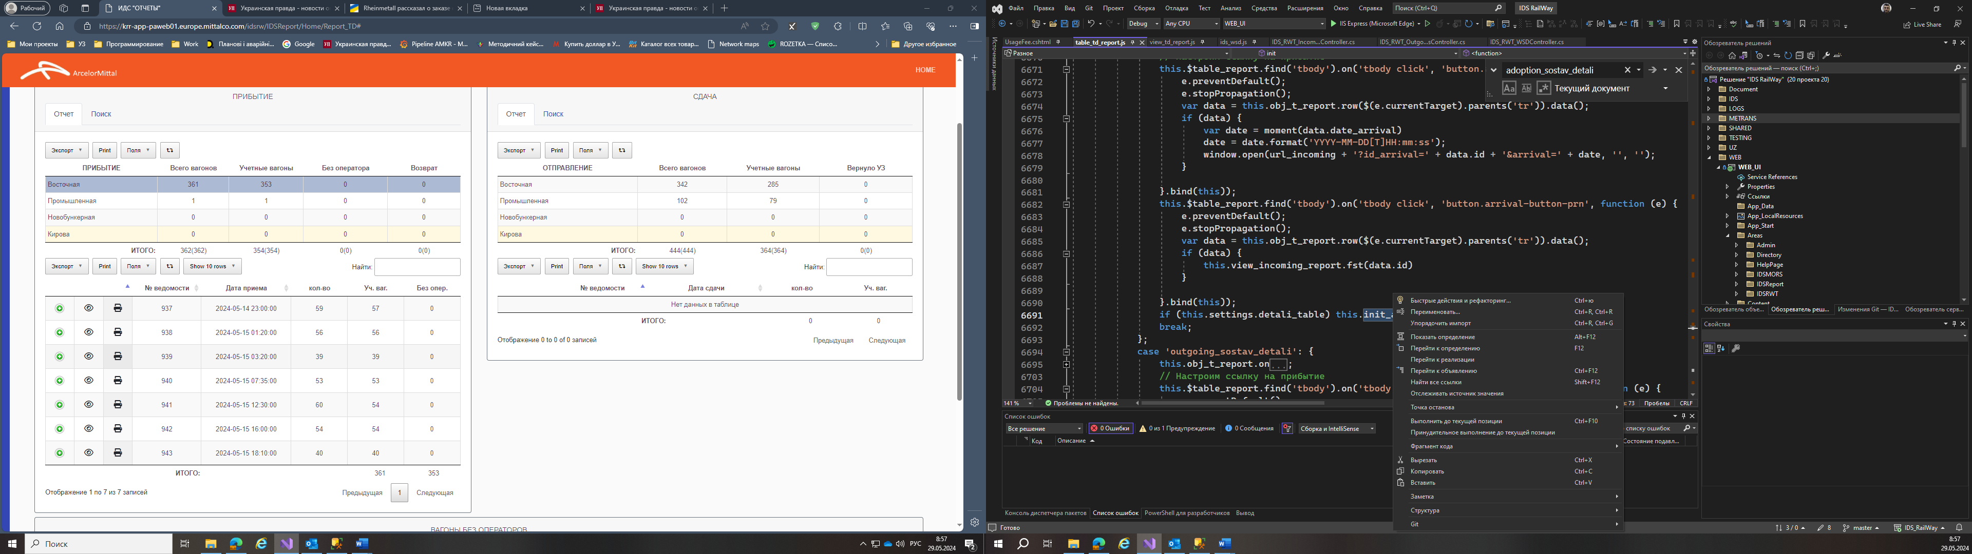table_td_report.js:

this.init_arrival_detali()

base.view_arrival_detali(data);

this.tables_detali[data.id]

this.load_incoming_cars_of_id_sostav(data.id, function (wagons)

this.ids_wsd.getViewIncomingCarsOfIDSostav(id_sostav, function (wagons)

IDS_RWT_Incoming_ArrivalCarsController.cs

select * from [IDS].[get_view_incoming_cars_of_id_sostav](@id_station) order by arrival_car_position

предыдущие отправки

this.ids_wsd.getViewPreviousOutgoingCarsOfIDWIR(el.id_wir, function (outgoing_car)

select * from [IDS].[get_view_outgoing_cars_of_id_car]((select [id_outgoing_car] from [IDS].[WagonInternalRoutes] where [id]= (select [parent_id] FROM [IDS].[WagonInternalRoutes] where [id]= @id_wir)))

- предыдущие отправки загружаем отдельно

this.ids_wsd.getViewPreviousOutgoingCarsOfIDWIR(el.id_wir, el.num, function (outgoing_car)

select * from [IDS].[get_view_adoption_sostav_of_period](@start,@stop)

“Отправка”

this.table_outg_sostav_all

this.ids_wsd.getReportOutgoingSostavOfPeriod(start, stop, function (result_sostav)

IDS_RWT_OutgoingSostavController

select * from [IDS].[get_view_outgoing_sostav_of_period](@start,@stop);

count_account_balance = ([IDS].[get_count_account_balance_of_outgoing_sostav](out_sost.id))

this.table_outg_sostav_detali

загрузка деталей по составу

* this.load_outgoing_cars_of_id_sostav

this.ids_wsd.getViewOutgoingCarsOfIDSostav(id_sostav, function (wagons)

1. Отчет остаток

report_10_1

this.ids_wsd.getReportViewOperatingBalanceOfDate(date, function (result_operating_balance)

select * from [IDS].[get_view_outgoing_cars_of_id_sostav](@id_station) order by outgoing_car_position

1. Отчет остаток (ИТОГ)

report_11_1

Загрузить данные отчета "Оператор"

this.ids_wsd.getReportViewOperators_OB_OfPeriod(start, stop, function (result_operator_ob)

"select * from [IDS].[get_view_operator_ob_of_period](@start, @stop)"